Saturday Point Champions 2025
Predator Purple
- Logan Fornof 814
- Makenna Glaister 806
- Timothy Steiner 780
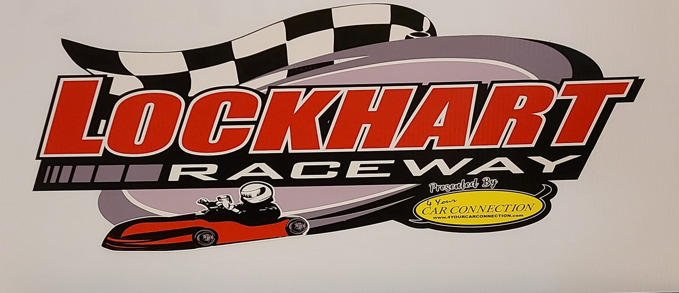
- Ayson Gregoire 680
Predator 325
- Chris Glaister 788
- Skyler Myers 669
79 CC
- Harrison Pearcy 840
- Hayzle Fornof 665
Predator Red
- Connor Bish 790
- Richard Robinson 696
- Cameron Harry 640
Clone 325
- Logen Lockhart 813
- Zander Lenhart 768
- Cooper Macormac 753

Clone Blue
- Sebastian Woodcock 740
Predator 375
- Scott Adams 779
- Skyler Myers 695
Clone 400
- Monty Frederick 870
- Jeff Davis 729
- Josh Barger 638
Clone Purple
- Kellen Reichel 825
- Landon Unverzagt 823
- Ayson Gregoire 650
Clone 375
- Monty Frederick 768
- Cameron Griffin 762
- Norm Griffin 680

